Automation

# Scripting Linux Server functions

Echo “Hello Bash Word!”

Nano to change the content

Do some simple calculation

Execute and get the calculation correct

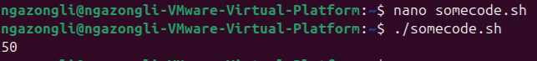

Modify to do loop code

Test output

Create file1 to file5 within /home/ubuntu/Documents

Create new folder testfolder and create file11 to file55

Create backup script in testscript

Allow the script be available system wide by moving it to the /usr/bin/

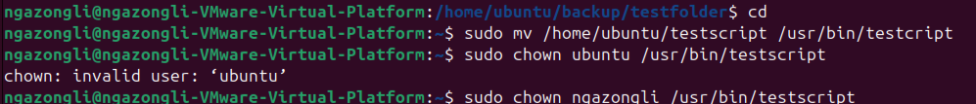

Check Path

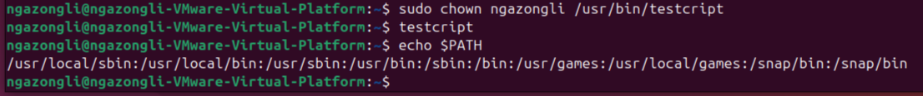

Create a variable in script called now and insert the date

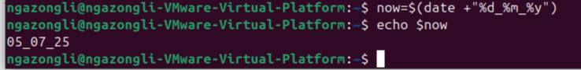

Zip fill name the archive as zippedfile

Zip successful

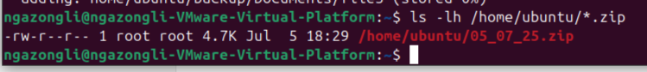

Run the script and backup

Modify cron to daily update at 9am

Check for the cron setup

Upload to cloud using scp command

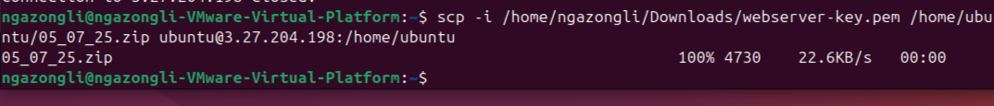

Sign in to cloud server

Check the backup folder inside the cloud server

